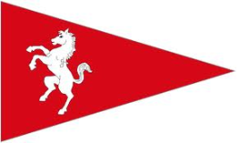
MYC Christmas Dinner
Wednesday 14 December

Cost £23.50 – payment at time of booking

Booking via the office payment at the time of booking

Starters
- Tomato & Basil Soup with a Pesto Cream
- Hot Smoked Salmon Salad with Balsamic & Rocket Salad
- Double Baked Cheese Soufflé with Onion Confit

Main
- Roast Norfolk Turkey Breast with Traditional Fayre
- Roast Sirloin of Beef with
- Seared Tuna with a Puy Lentil Salad
- Vegetarian upon Request

served with seasonal Vegetables & Roasted Potatoes

Deserts
Traditional Christmas Pudding with Brandy Sauce
Warm Chocolate Fondant with Pistachio Ice Cream*
Vanilla Pannacotta with Raspberry Confit

*Allergy advice: contains nuts Vegetarian option on request

Name | Starter | Main | Desert

Bank transfer quoting reference: Cdinner Your name (please ensure that you quote the reference)

Account: Medway Yacht Club
Bank: Handelsbanken
Sort Code: 40-51-62
Account: 69656844

Cash, cheque and debit card also accepted

