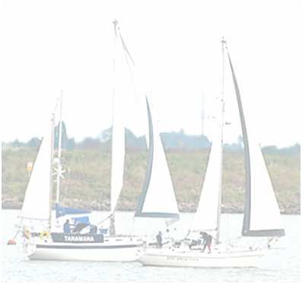
Medway Cruising Club

Autumn Series 2016

Start Times | Cruiser  Provisional Start Times PLEASE be aware of different start times | Gaffer  Start Times | Time Limit | LW | Approx Time Racing
Sunday 4th September | 10.00 Autumn 1 | No racing | 17.00 | 09.34 0.6 | 4-5hrs
Saturday 10th September | REYC Mary Cup 10.00 | 10.10 Aut1 | 17.00 | 11.38 1.5 | 4-5hrs
Sunday 11th September | 10.00 Autumn 2 & Burton 1 | 10.10 Aut2 | 17.00 | 14.34 1.5 | 4-5hrs
Sunday 18th September | 11.00 Autumn 3 & Burton 2 | No racing | 17.00 | 08.34 0.4 | 4-5hrs
Saturday 24th September | No Racing - Spare Day | 10.10 Aut3 | 17.00 | 12.36 1.1 | 4-5hrs
Sunday 25th September | 10.00 Autumn 4 & Burton 3 | 10.10 Aut4 | 17.00 | 14.44 1.3 | 4-5hrs
Sunday 2nd October | 11.00 Autumn 5 & Burton 4 | No racing | 17.00 | 08.34 0.6 | 4-5hrs
Saturday 8th October | No Racing - Spare Day | 10.10 Aut5 | 17.00 | 10.26 1.0 | 4-5hrs
Sunday 9th October | 10.00 Autumn 6 & Burton 5 | 10.10 Aut6 | 17.00 | 11.10 1.2 | 4-5hrs

Entry cost FOC
For further information and entry form contact:

Andy Homer
MCC Sailing Secretary
Tel: 07761 790610
Email:andy.homer@outlook.com
www.medwaycruisingclub.org.uk

